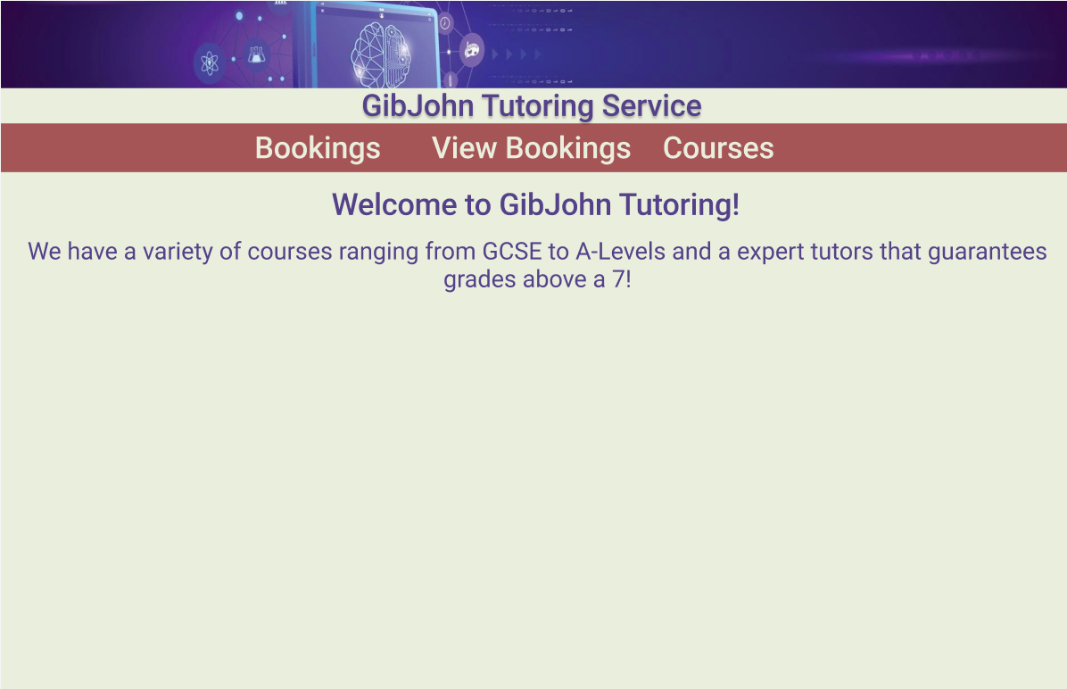
Home Page:
I have chosen this design and colour scheme as it makes the text easy to view and read incase the user is hard of sight and the navigation bar is simple but easy to use to help users be able to use the website with ease

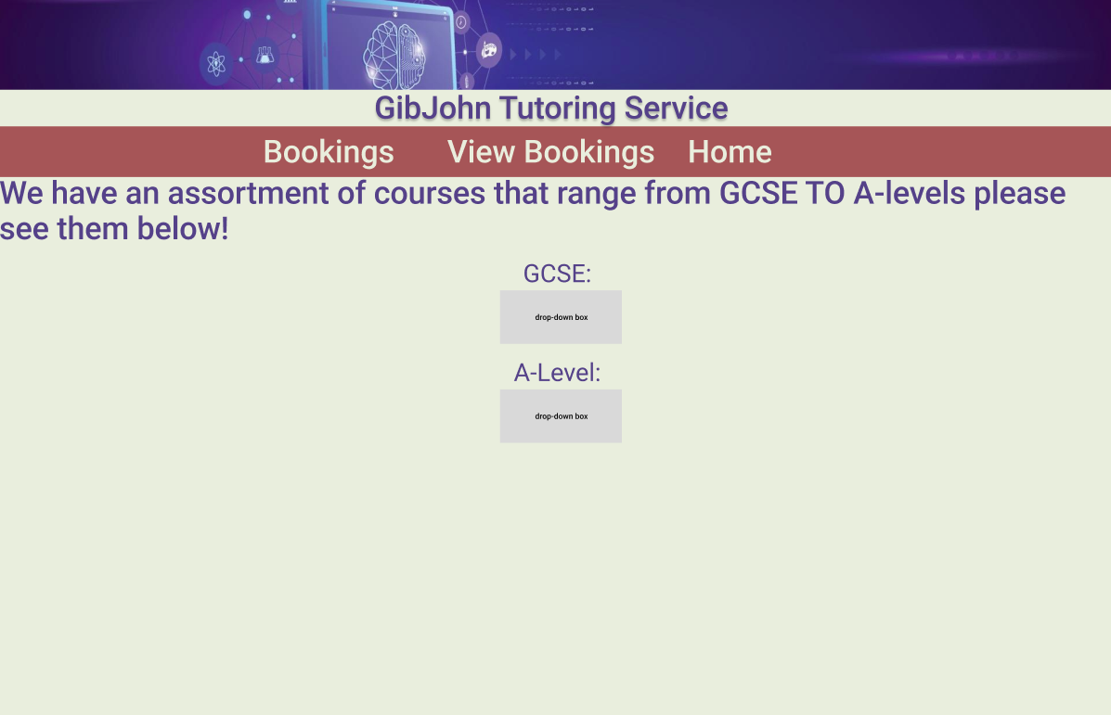
Courses Page:
I have designed this page to look like this as it makes is easy to view the options.

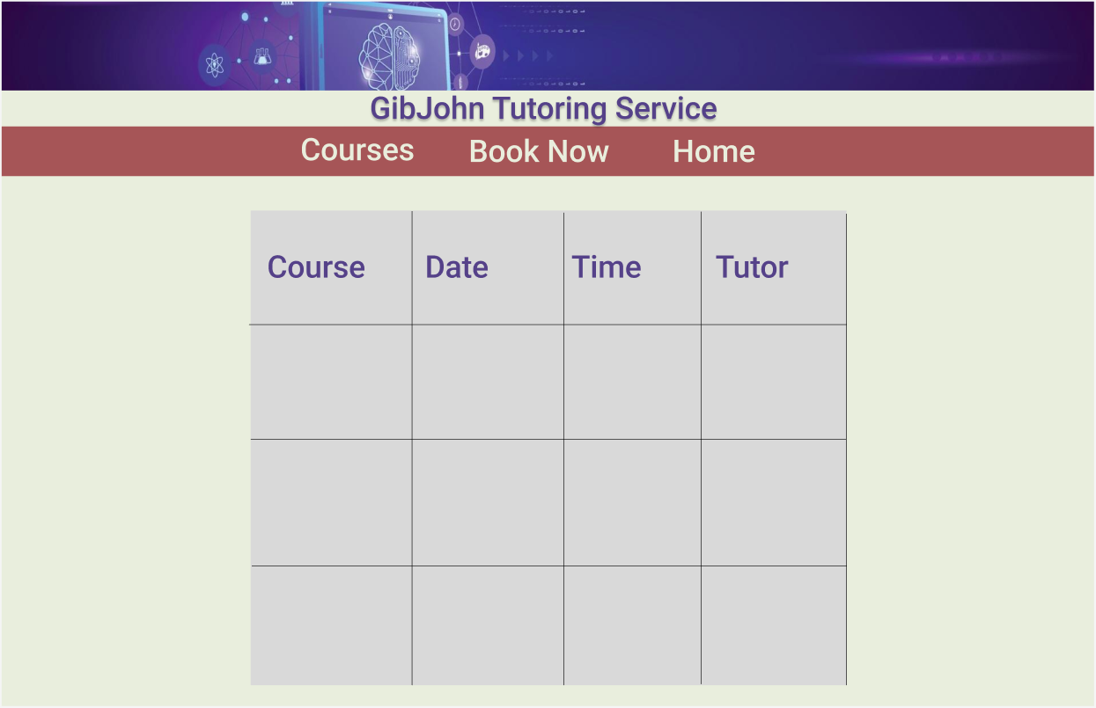
Bookings page:
I have chosen this design as it make knowing what lesson you have when much simpiler, I need to add a way to log in to increase security and so the right people know what course they are on

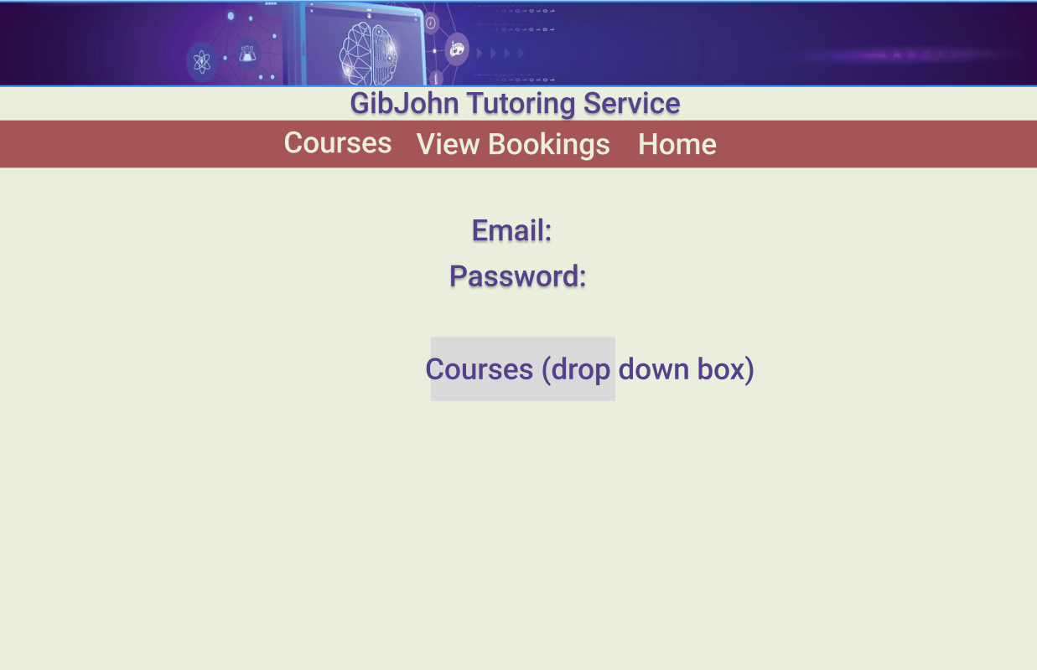

Booking Page:

I have chosen this design because I want my website to be simple and easy to use, when I have coded this is have added a couple of extra fields such as time of lesson and will add a password box to increase security.

